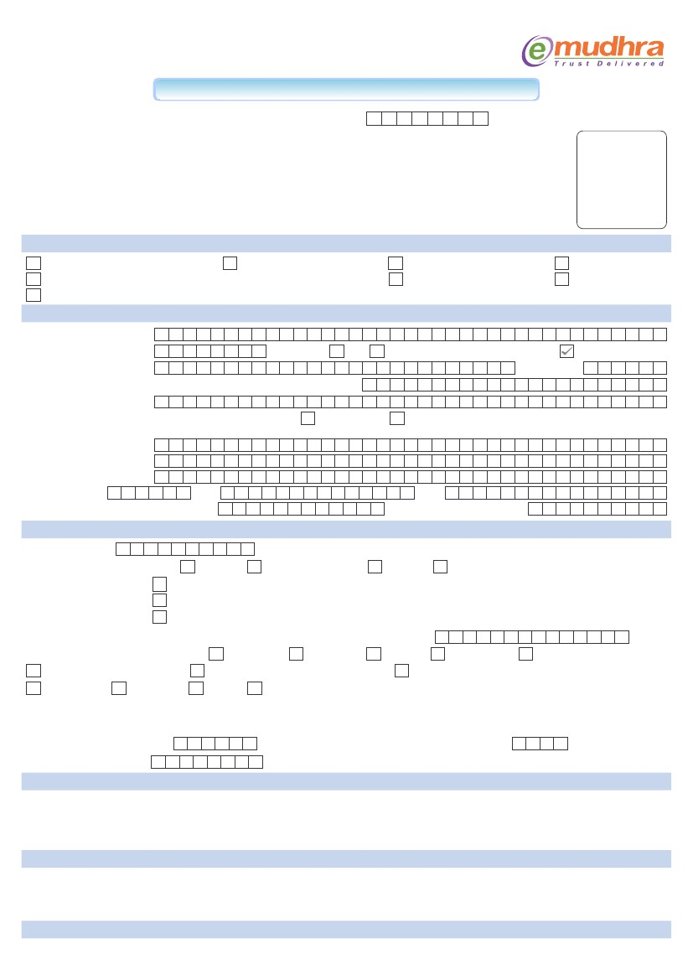
APPLICATION FOR DIGITAL SIGNATURE CERTIFICATE - FOR INDIVIDUAL
Instructions:
Application ID Number (For office use only):
1. Please fill the form in BLOCK LETTERS and (*) MARKED Fields are Mandatory.
2. Inconsistent/incomplete applications are liable to be rejected.
3. (**) Attestation of documents by any: Gazetted Officer OR Bank Manager OR Post Master OR present originals to our Registration Authority for verification & attestation.
4. All subscribers are advised to read Certification Practice Statement and subscriber agreement of eMudhra available at www.e-mudhra.com
5. At par cheques/Demand draft drawn in favour of eMudhra Consumer Services Limited payable at Bangalore
6. All customer documents need to be self attested by the customer over and above the third party attestation
7. For Class III Digital Signatures “In Person Verification” of the applicant is mandatory
Affix
recent passport
photograph of the
applicant duly
signed across
1A. CERTIFICATE CLASS*
Class 1 Silver Individual
Class 2 Gold Individual
Class 3 Platinum Individual
1B. CERTIFICATE TYPE*
Signature
2. CERTIFICATE VALIDITY*
1 Year
3. USB TOKEN*
Required
Not Required
APPLICANT DETAILS* (As per applicant's valid ID Proof and Address Proof at SI.No.1 & 14 below)
4. Name:* Mr./Ms./Dr.
5. Date of Birth:*
8. Father/ Spouse Name*:
10. eMail ID* (Valid and active E-mail ID to be included in the Digital Signature Certificate)
11. (++) Address for communication :
Residence
Office
(As per proof Submitted)
F
I R S T N A M E
M M Y Y Y Y
M I D D L E N A M E
L A S T N A M E
D D
6. Gender:*
Male
Female
7. Residential Status:*
Resident
9. Nationality I N D I A N
(Door No., Name of the premises, Road, Area, City, State and Pin code needs to be filled)
Pincode
Telephone No. (e.g. +91-80-23333333)
City
State
Check list for IDENTIFICATION and DOCUMENTATION DETAILS*
Mobile No. (e.g. + 91-9999999999)
12. PAN Number :
13. Valid Identity Documents : *
Passport
Attested copy of PAN Card is mandatory for obtaining Certificate with PAN
Copy of Driving License
PAN card
Post Office ID Card
Bank Account Passbook containing the Photograph and signed by an individual with attestation by the concerned Bank official
Photo ID Card issued by the Ministry of Home Affairs of Centre/State Government
Any Government issued photo ID Card bearing the signature of the individual
(Please tick any one and fill the ID number and attach attested (**) copy of ID proof)
14. Valid Address Proof Documents : *
e) Bank Statements signed by the Bank
h) Driving Licence
i) Voter ID Card
a) Telephone Bill
b) Electricity Bill
ID Proof Number:
c) Water Bill
d) Gas Connection
f) Service Tax /VAT/Sales Tax registration certificate
j) Passport
g) Property Tax/Corporation/Municipal corporation receipt
k) Certificate of Registration for owned Vehicle
(Please tick any one and fill the Document number and attach attested (**) copy of address proof) Doc No. ___________________________________________
Note: For A to E the date of last transaction should not be older than 3months, for S.No. F & G the same should be pertain to the current financial year.
All documents should have the complete address for the purpose of accepting the same as proof.
15. Payment Details : Cheque / DD No.
Date
D D
M M Y Y Y Y
Other Modes: ___________________________
Amount Rs.
Bank: _________________________________________________________________
DECLARATION*
I hereby agree that I have read and understood the provisions of e-mudhra Certification Practice Statement (CPS) and the subscriber agreement and will abide by the same. The information provided in this Digital Signature Certificate request form is true and correct to the best of my knowledge and I accept publishing my certificate information in e-Mudhra repository.
:
Seal & Stamp [If available]:
Signature of the applicant
TO BE FILLED BY RA OFFICE ONLY*
I declare that the applicant has provided correct information in this application form. I have checked and verified the application form and supporting documents.
RA Code & Name/ Seal :
Signature:
Date:
Place:
CONTACT DETAILS:
Application Form for Emudhra Digital Signature along with verification documents should only be sent to EMASTERSINDIA.NET, Kolkata Office: 33, Townshend Road Ground floor. Purnashish Building.
Kolkata: 700025, Ph: 033 – 24755213, 32997981 Mobile: 9331707877; Email:info@emastersindia.net, Account Details: HDFC Bank, Central Plaza, Kolkata, A/C No. Emastersindia.Net, A/C No.00142000024323., IFSC HDFC0000014

